GraphUsingHashTable.py takes a csv file that contain the Graphs and with their nodes and edges respectively.

There are some rules for csv file:

1. The '#' works as a separator to separate Graphs.

2. Just below the '#' cell specify ‘,’ (comma) separated vertices.

3. Below that cell there is bunch of pair or cells that represents edges.

4. '!' is use as End Of File.

In this Folder 'DataSet' there is a sample csv files.

Load that csv file (or csv file created by you) by load() function.

Our Graphs in our csv file looks Like:

Graph 1:

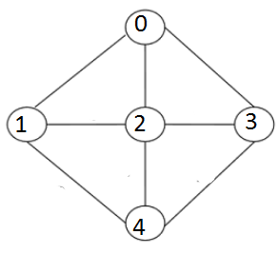

Graph 2:

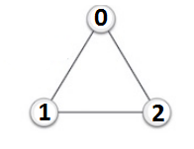

Graph 3:

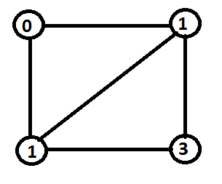

Graph 4:

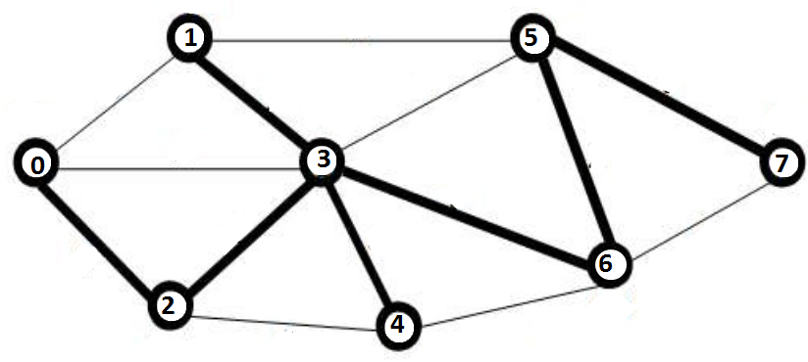

Graph 5:

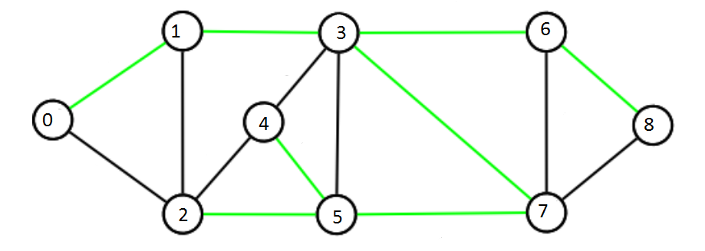

Graph 6:

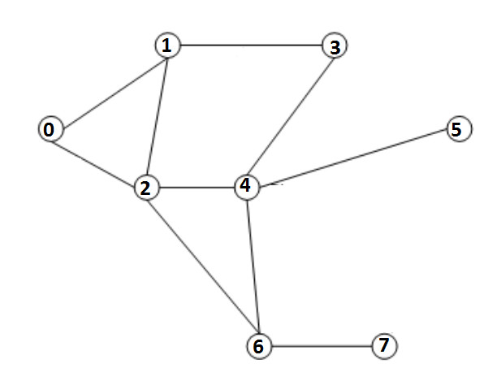

Graph 7:

